**MAILBOOTH**

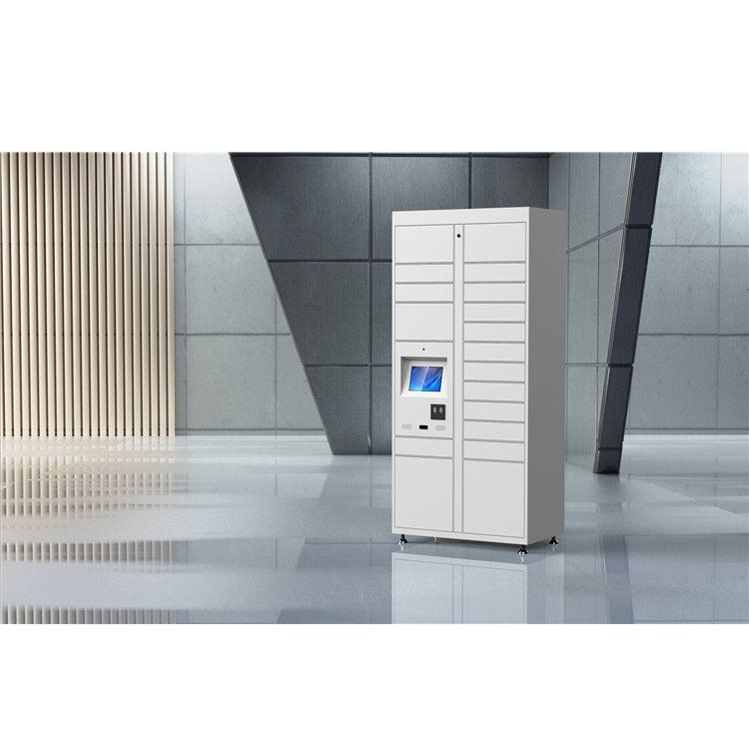

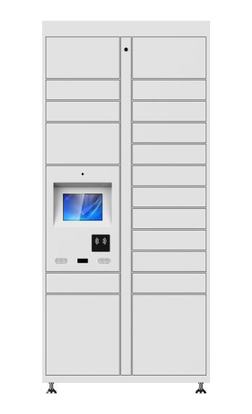

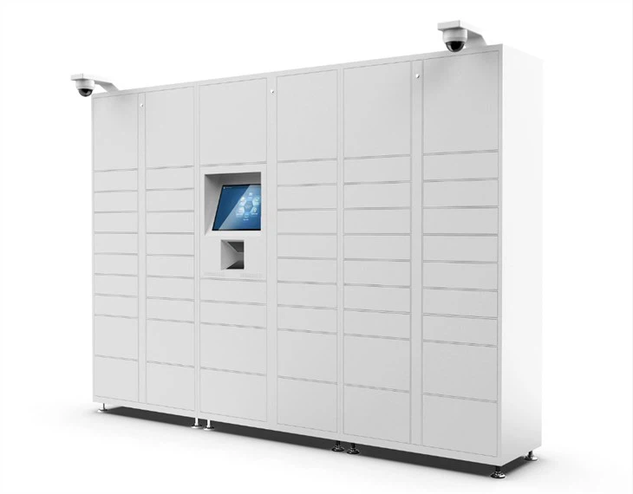

|  |  |  |  |  |  |  |
| --- | --- | --- | --- | --- | --- | --- |
| **HOME** | **ABOUT US** | **HOW IT WORKS** | **LOCATIONS** | **OUR PARTNERS** | **CONTACT US** | |
|  |  |  |  | 1. Existing Courier companies | |  |
|  |  |  |  | 2. Partner with us |  |  |

1. **HOMEPAGE**

**Welcome to Mailbooth - Simplifying Courier Services**

At Mailbooth, we're revolutionizing the way you send and receive couriers. Our mission is to provide convenient, reliable, and efficient courier services by partnering with grocery stores and courier companies to install physical mailbooths in strategic locations across India and Canada.

**Our Mission:**

At Mailbooth, our mission is to make courier services more accessible and hassle-free for everyone. By partnering with grocery stores across India and Canada, we're bringing our innovative mail booths right to your neighborhood, making it easier than ever to send your parcels securely and swiftly.

**How It Works**

Sending a courier with Mailbooth is as easy as 1-2-3:

1. **Insert Courier**: Simply place your courier in one of our designated mailbooths located in partnered grocery stores.
2. **Select Delivery Speed**: Choose your preferred delivery speed from our available options displayed on the screen.
3. **Relax and Track**: Sit back and relax as our partnered courier companies, including Indian Post, Blue Dart, Porter, and Gajanan Courier Services, ensure timely delivery to your desired destination.

**Why Choose Mailbooth?**

* **Convenience**: Our mailbooths are conveniently located within grocery stores, making it effortless for you to drop off your courier while running errands.
* **Reliability**: Partnering with trusted courier companies guarantees reliable and secure delivery of your parcels.
* **Speed Options**: Select from a range of delivery speeds to suit your urgency, ensuring your courier reaches its destination on time.
* **Transparency**: Track your courier every step of the way, knowing exactly when it's picked up and delivered.

**Our Partnerships:**

We're proud to collaborate with esteemed courier companies like Indian Post, Blue Dart, Porter, and Gajanan Courier Services to ensure seamless delivery of your parcels. With our extensive network, we guarantee swift and reliable delivery within specified radiuses, tailored to meet your unique needs.

**Find Us**

Explore our growing network of mailbooth locations across India and Canada. Easily locate the nearest mailbooth in your city or neighborhood.

**Get Started**

Ready to experience the convenience of Mailbooth? Find a nearby location, drop off your courier, and let us take care of the rest!

**Have Questions? Contact Us**

Have inquiries, feedback, or interested in partnership opportunities? Reach out to us via our inquiry form, email, phone, or visit us at our physical address. We're here to assist you every step of the way.

1. **ABOUT US**

About Mailbooth

Welcome to Mailbooth, where convenience meets innovation in the world of courier services. Founded with a vision to simplify the process of sending and receiving parcels, Mailbooth is revolutionizing the way people interact with mail and courier services across India and Canada.

Our Vision

At Mailbooth, our vision is clear: to create a seamless and accessible platform for individuals and businesses to send and receive packages with ease. We strive to be the go-to solution for anyone seeking hassle-free courier services, making sending parcels as simple as a trip to the grocery store.

Our Mission

Our mission is to bridge the gap between convenience and efficiency in the courier industry. By partnering with grocery stores and courier companies, we aim to install mail booths in as many locations as possible, providing a network of accessible drop-off points for our customers. Through these partnerships, we ensure that sending a parcel is not only effortless but also reliable and swift.

Our Values

Transparency, reliability, and customer satisfaction are at the core of everything we do at Mailbooth. We believe in transparency in our operations, ensuring that our customers are informed and empowered throughout the courier process. Our commitment to reliability means that you can trust us to deliver your parcels safely and on time, every time. And above all, we prioritize customer satisfaction, striving to exceed expectations with every interaction.

Meet the Team

Behind Mailbooth is a dedicated team of professionals who are passionate about revolutionizing the courier industry. From logistics experts to customer service representatives, each member of our team plays a crucial role in bringing our vision to life. Get to know the faces behind Mailbooth and discover the people working tirelessly to make your courier experience seamless and stress-free.

Join Our Journey

Are you ready to join us on our mission to redefine courier services? Whether you're a customer looking for convenient shipping solutions or a business interested in partnering with us, we welcome you to be a part of the Mailbooth journey. Together, let's shape the future of courier services and make sending parcels easier than ever before.

Our Commitment to Sustainability

At Mailbooth, we are committed to reducing our environmental impact and promoting sustainable practices. By providing a centralized drop-off point for parcels, we aim to minimize the carbon footprint associated with individual trips to courier offices. Additionally, we are exploring eco-friendly packaging options and optimizing delivery routes to further reduce emissions and waste. Together, we can make a difference for our planet while enjoying the convenience of Mailbooth's services.

Community Engagement

We believe in giving back to the communities we serve. Through partnerships with local organizations and charitable initiatives, we strive to make a positive impact beyond the realm of courier services. Whether it's supporting local events, sponsoring community projects, or volunteering our time, Mailbooth is dedicated to being a responsible corporate citizen and contributing to the well-being of our neighborhoods.

Continuous Improvement

At Mailbooth, we are committed to continuous improvement and innovation. We actively seek feedback from our customers and partners to identify areas for enhancement and refinement. By staying agile and adaptable, we ensure that our services evolve to meet the changing needs of our users and the industry as a whole. Your input is invaluable to us as we strive to deliver the best possible courier experience.

Our Promise to You

When you choose Mailbooth, you're not just choosing a courier service – you're choosing convenience, reliability, and peace of mind. We promise to always put our customers first, providing exceptional service and support every step of the way. Whether you're sending a gift to a loved one or shipping products for your business, you can trust Mailbooth to deliver with care and efficiency.

Join the Mailbooth Community Today

Ready to experience the future of courier services? Join the Mailbooth community today and discover a new level of convenience and efficiency. Whether you're a frequent sender or an occasional shipper, we're here to make your life easier. Welcome to Mailbooth – where sending parcels is as easy as dropping them off at your local grocery store.

* 1. **OUR INNOVATION**

**Our Innovation**

At Mailbooth, we're committed to revolutionizing the courier industry with our innovative approach to parcel delivery. Our mission is to provide seamless and convenient courier services by installing mail booths in grocery stores across India and Canada. Here's how we're innovating:

Convenient Mail Booth Installation

We partner with grocery stores to install mail booths conveniently within their premises. These booths serve as accessible drop-off points for customers to conveniently send their parcels.

Easy Parcel Drop-off Process

Sending a parcel through Mailbooth is as simple as inserting it into the booth. Customers can easily drop off their parcels without the need for complicated forms or long wait times.

Delivery Speed Options

Upon dropping off their parcel, customers can select their desired delivery speed options directly on the booth's screen. We offer a range of delivery speeds to suit different needs.

Partnership with Courier Companies

To ensure timely and reliable delivery, we partner with renowned courier companies like Indian Post, Blue Dart, Porter, and Gajanan Courier services. Each courier company specializes in delivering parcels within specific radiuses, ensuring efficient service.

Aggregator Service

Mailbooth acts as an aggregator service, partnering with grocery stores and courier companies to streamline the parcel delivery process. By installing physical mail booths in grocery stores, we make it easy for customers to send their parcels conveniently.

Customer Details Collection

To facilitate smooth delivery, we collect sender and receiver details including full name, email ID, contact number, and full residential address. This ensures accurate and efficient parcel delivery.

Timely Parcel Delivery

Our courier partners offer varying delivery times based on distance. For instance, Indian Post delivers within a 20 km radius in 48 hours, while Porter delivers within a 150 km radius in just 3 hours.

Commitment to Customer Convenience

At Mailbooth, we're dedicated to providing exceptional service and convenience to our customers. Our innovative approach to parcel delivery ensures a seamless experience from drop-off to delivery.

Join us in embracing the future of courier services. Experience the convenience of Mailbooth today!

* 1. **HOW IT WORKS**

How It Works

Sending a parcel through Mailbooth is quick, easy, and hassle-free. Follow these simple steps to send your package with confidence:

1. Locate Your Nearest Mailbooth

Find the nearest Mailbooth location by visiting our website or using our mobile app. With Mailbooth's expanding network of partner grocery stores, you're never far from a convenient drop-off point.

1. Prepare Your Parcel

Ensure your parcel is securely packaged and labeled with the recipient's address. Remember to include your full name, email ID, contact number, and residential address for seamless processing.

1. Visit the Mailbooth

Head to your chosen Mailbooth location during business hours. Our mail booths are conveniently located within partner grocery stores, making it easy to drop off your parcel while running errands or shopping for groceries.

1. Insert Your Parcel

Once at the Mailbooth, follow the on-screen prompts to open the door and insert your parcel securely. Our intuitive interface will guide you through the process, ensuring your package is safely deposited inside the booth.

1. Select Your Delivery Speed

Choose from a range of delivery speed options to suit your needs. Whether you require express delivery or standard shipping, Mailbooth offers flexible choices to accommodate your preferences.

1. Confirm Your Details

Review the sender and recipient details displayed on the screen to ensure accuracy. If everything looks correct, confirm your selection to proceed with the courier process.

1. Receive Confirmation

Upon confirmation, you'll receive a digital receipt and confirmation of your parcel's acceptance. Rest assured that your package is in safe hands and on its way to its destination.

1. Track Your Parcel

Stay informed throughout the delivery process by tracking your parcel's progress online or through our mobile app. Receive real-time updates on its location and estimated delivery time, giving you peace of mind every step of the way.

Experience the Convenience of Mailbooth Today

With Mailbooth, sending parcels has never been easier. Say goodbye to long queues and complicated shipping processes – and hello to convenience, reliability, and efficiency. Join the Mailbooth revolution and simplify your courier experience today!

* 1. **LOCATIONS**

Find Your Nearest Mailbooth Location

Mailbooth is proud to serve customers across Canada and India, providing convenient drop-off points for your parcels at partner grocery stores. Explore our expanding network of locations below to find the nearest Mailbooth to you:

Canada:

1. Toronto, Ontario
   * Maple Leaf Grocers
   * Downtown Mart
   * Lakeside Supermarket
2. Vancouver, British Columbia
   * Pacific Fresh Market
   * Urban Pantry
   * Mountain View Grocery
3. Montreal, Quebec
   * Belle Épicerie
   * City Market
   * La Petite Boulangerie

India:

1. Mumbai, Maharashtra
   * Metro Mart
   * City Superstore
   * Green Valley Grocers
2. Delhi, Delhi NCR
   * Big Basket
   * Urban Fresh
   * Daily Needs Supermarket
3. Bangalore, Karnataka
   * Fresh Mart
   * Garden Grocers
   * Quick Stop

Please note that our list of locations is continually growing as we expand our reach to serve more communities. Check back regularly for updates on new Mailbooth locations near you!

Experience Convenience, Close to Home

With Mailbooth, sending parcels is as easy as visiting your local grocery store. Our strategically placed mail booths make it convenient to drop off your packages while running errands or shopping for essentials. Say goodbye to long queues and complicated shipping processes – and hello to convenience, reliability, and efficiency with Mailbooth.

Ready to Simplify Your Courier Experience?

Visit one of our partner grocery stores today to experience the future of courier services with Mailbooth. We're here to make sending parcels easier than ever before. Find your nearest location and start shipping with confidence!

Discover More About Our Partnered Locations

**3) BOOK MY SHIPMENT**

Sender details:

Full name:

Contact no:

Email Id:

Select Country: (Canada or India)

Address:

Receiver details:

Full name:

Contact no:

Email Id:

Select Country: (Canada or India)

Address:

BOOK NOW

**Select a courier partner:**

1. **Indian Post**

Description: Indian Post is a reliable postal service provider known for its widespread network and affordable rates. With Mailbooth, you can enjoy the convenience of Indian Post's services within a 20 km radius, delivering your parcels safely and efficiently.

1. **Blue Dart**

Description: Blue Dart is a leading logistics company renowned for its express delivery services and nationwide coverage. Through our partnership with Blue Dart, we offer expedited shipping options within a 40 km radius, ensuring swift delivery of your parcels to their destination.

1. **Porter**

Description: Porter specializes in rapid courier services, catering to time-sensitive deliveries within a 150 km radius. With Mailbooth, you can leverage Porter's efficient delivery network to send your parcels with speed and precision.

1. **Gajanan Courier Services**

Description: Gajanan Courier Services is known for its reliable and cost-effective courier solutions, serving customers within a 30 km radius. With Mailbooth, you can trust Gajanan Courier Services to deliver your parcels promptly and securely to their intended recipients.

PROCEED TO PAYMENT

**Track your Shipment:**

**Expected Delivery date:**

[Logic: Here, the customer should be able to track his/her shipment. He should be able to see currently exactly where his courier is and what is the expected delivery date]

**4) OUR PARTNERS**

**5.1 Our Partners**

Welcome to the Our Partners page, where we showcase the valued organizations that help make Mailbooth a seamless courier solution in Canada and India. Explore our existing courier partners and learn how you can join forces with us to revolutionize the courier industry.

Existing Courier Companies

At Mailbooth, we're proud to collaborate with reputable courier companies to ensure reliable and timely delivery of your parcels. Our existing partners are trusted names in the industry, each offering specialized services tailored to meet your shipping needs:

1. Indian Post
   * Description: Indian Post is a reliable postal service provider known for its widespread network and affordable rates. With Mailbooth, you can enjoy the convenience of Indian Post's services within a 20 km radius, delivering your parcels safely and efficiently.
2. Blue Dart
   * Description: Blue Dart is a leading logistics company renowned for its express delivery services and nationwide coverage. Through our partnership with Blue Dart, we offer expedited shipping options within a 40 km radius, ensuring swift delivery of your parcels to their destination.
3. Porter
   * Description: Porter specializes in rapid courier services, catering to time-sensitive deliveries within a 150 km radius. With Mailbooth, you can leverage Porter's efficient delivery network to send your parcels with speed and precision.
4. Gajanan Courier Services
   * Description: Gajanan Courier Services is known for its reliable and cost-effective courier solutions, serving customers within a 30 km radius. With Mailbooth, you can trust Gajanan Courier Services to deliver your parcels promptly and securely to their intended recipients.

**5.2 Partner with Us**

Are you a grocery store owner or a courier company interested in partnering with Mailbooth? We're always seeking new collaborations to expand our network and enhance our services. Partnering with Mailbooth offers a range of benefits, including increased foot traffic, enhanced customer convenience, and access to a growing customer base.

To partner with us, simply fill out the contact form below with your details, and a member of our team will reach out to discuss potential collaboration opportunities. Let's work together to simplify courier services and deliver exceptional value to customers across Canada and India.

Join the Mailbooth Network Today

Whether you're an existing courier company or interested in partnering with us, Mailbooth offers exciting opportunities for collaboration and growth. Contact us today to learn more about partnering with Mailbooth and becoming part of our success story.

**6) CONTACT US**

We're here to assist you with any inquiries, feedback, or partnership opportunities. Contact Mailbooth using the information provided below, and a member of our team will be happy to assist you.

**General Inquiries:**

Have a question about Mailbooth's services or operations? Need assistance with your parcel delivery? Contact our customer support team for prompt and helpful assistance.

Email: info@mailbooth.com Phone: +91 9821338220 (India) Operating Hours: Monday to Friday, 9:00 AM - 5:00 PM (local time)

**Partnership Opportunities:**

Interested in partnering with Mailbooth to expand your business or offer additional services to your customers? We're always looking for innovative collaborations with grocery stores and courier companies.

Email: info@mailbooth.com Phone: +91 9821338220 (India) (India) Operating Hours: Monday to Friday, 9:00 AM - 5:00 PM (local time)

**Physical Address:**

Visit us at our headquarters to learn more about Mailbooth and meet our team in person. We'd love to hear from you and discuss how we can work together to simplify courier services.

**Address:**

India Office: 905-B, Hilla Tower, Dr.S.S.Road, Lalbaug, Mumbai - 400012

Canada Address: Mail Booth, 175 Longwood Rd S Suite B21, Hamilton, ON L8P 0A1, Canada

**Get in Touch:**

Fill out the contact form below to send us a message directly. Please provide your name, email address, phone number, and a brief description of your inquiry or feedback. A member of our team will respond to your message as soon as possible.

**Contact Us Form:**

Name:

Contact Us:

Email:

Thank you for choosing Mailbooth. We look forward to serving you and providing you with the convenience and reliability you deserve.